Kubernetes Task-07
Taints:
1. NoSchedule
Switch to root user
Check the list of nodes
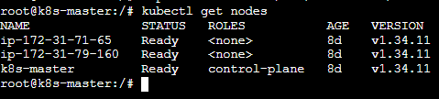
We see that no rule is set for taint in below screenshot:
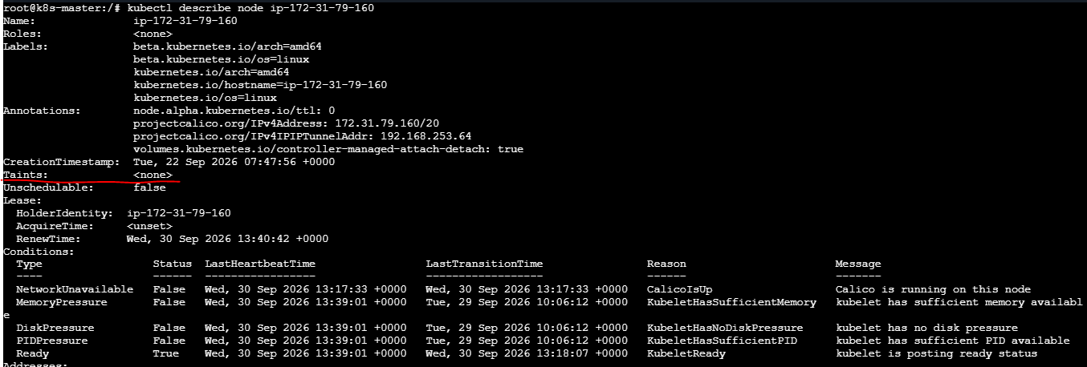
When set the taint rule it shows that our worker1 is tainted
Now when verified using kubectl describe node, we see that rule is set for worker1
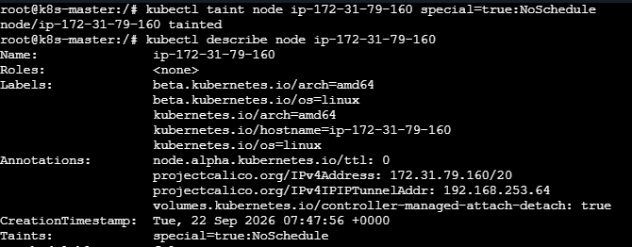
Create a pod using yaml script:
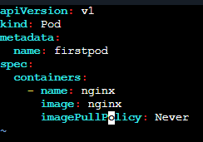
Save and exit.
Apply it. We see that a pod is created.
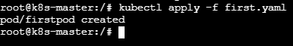
Verify it: We see that pod is scheduled on worker 2 not on worker1.
NoSchedule : Prevents new Pods from being scheduled on the node.

2. NoExecute:
Now apply taint on worker1 with Noexecute:
When verified we see that existing pod is also deleted hence it shows no resources.
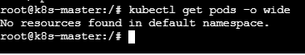
NoExecute : Prevents new Pods and can evict existing Pods that don't tolerate the taint.

Now even if we try to apply pods then it shows pending
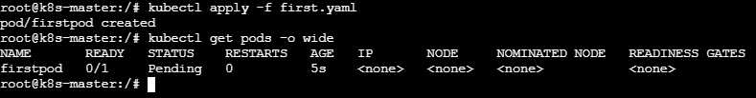

Untaint/Remove taint on worker2:
No when we verify, we can see pod is scheduled on worker2:
3. PreferNoSchedule:
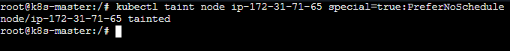
we see that it is scheduled on worker2 as the rule was applied after creating the pod
Now when we delete pod and create the pod again and apply it, as not preferred it scheduled pods on worker2
Untaint worker2:
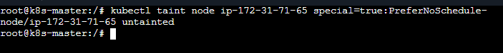
Tolerations: Add tolerations to first.yaml script:
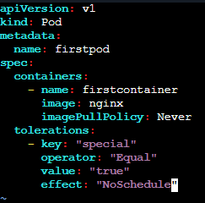
Save and exit.
Apply it and see the pod is created.
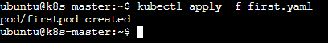
As taint is on worker2 and toleration is applied on firstpod, here the taint is matched with toleration on worker2 and thus pod is scheduledon worker2
Tolerationseconds:
Create a pod using yaml and add
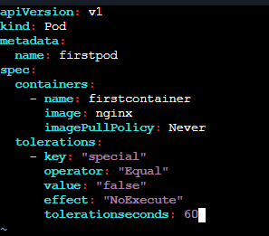
Save and exit.
Apply it:
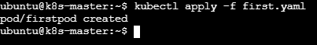
Trying to apply taint NoExecute with key value false and tolerationseconds = 60 on worker 1
After 60 seconds running pod gets deleted
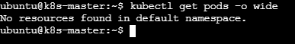
Node selector:
Check the labels attached to the machines:
Below are the default labels attached to master, worker1 and worker2
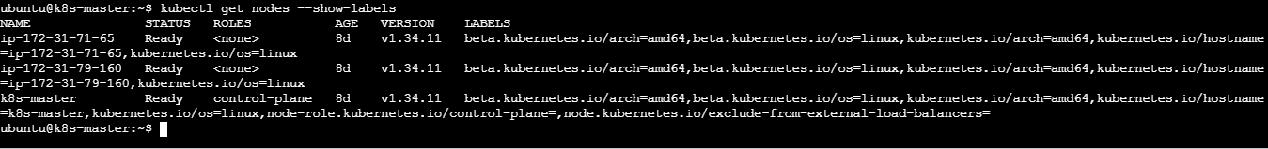
Add own label to worker1:
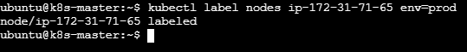
Verify it:
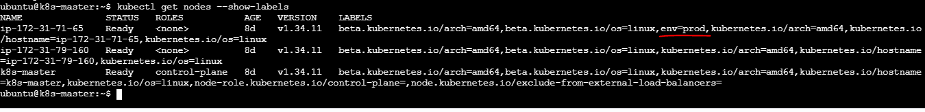
Now create a pod using yaml:
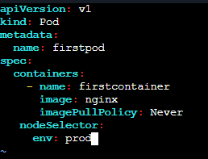
Save and exit.
Apply it:
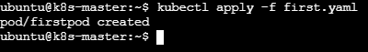
When verified we see that pod is scheduled on worker1 as labeled for worker1
Create another pod and add:
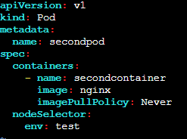
Save and exit.
Apply it:
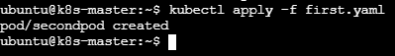
Verify it:
As there is no label test it will not schedule pod
Now label worker2 with env =test
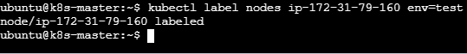
Verify it:
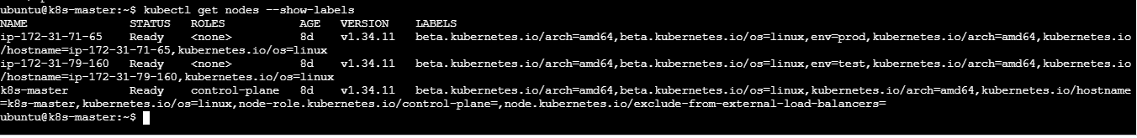
We see that pod is scheduled on worker2:
Unlabel the node worker1:
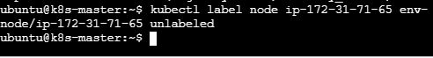
Even after removing the label, pods will be still up and running:
Verify to see label been removed on worker1:
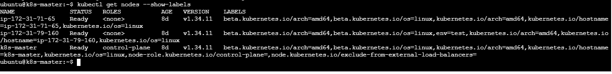
Node Affinity:
Soft scheduling
Create a pod using yaml and add:
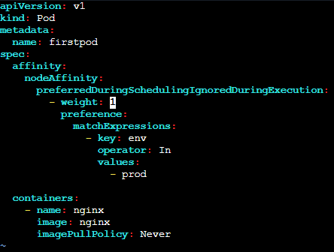
Save and exit.
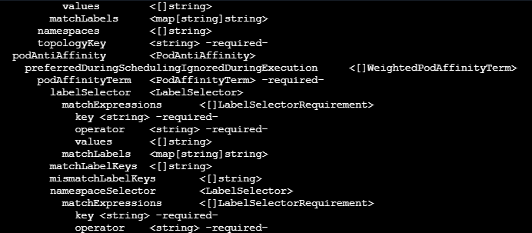
Apply it:
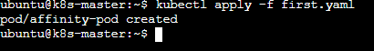
Verify it: We see that pod is scheduled on worker1
First it checked for the env =prod as this is the preferred one and as it doesn’t exist it checked for any other label is present and found test and scheduled on that label.
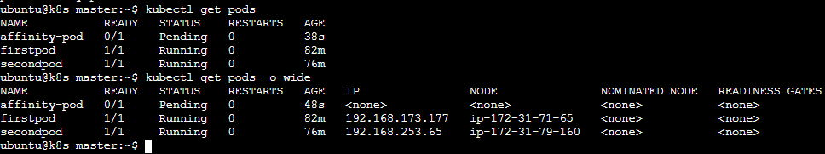
Hard scheduling: Using In
Create a pod for required during scheduling using yaml and add:
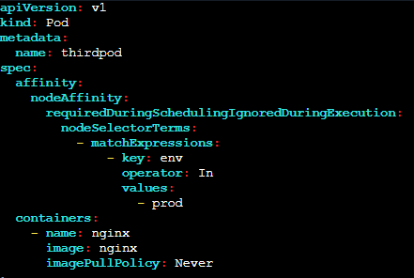
Save and exit.
Apply it:
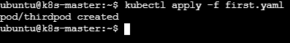
Verify:
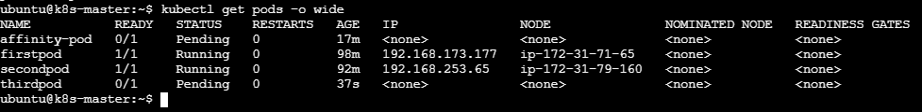
As there no env=prod it is not been scheduled.
Using: NotIn
Create a pod using yaml and add
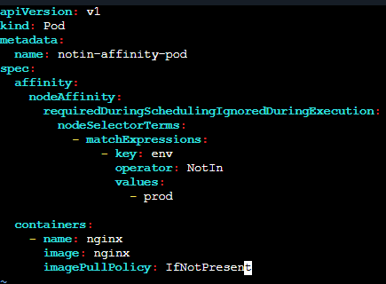
Save and exit.
Apply it:
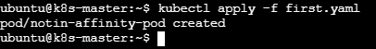
Verify:

Task 2: Taint a Node and Schedule a Tolerant Pod Taint a node with special=true:NoSchedule. Create a pod with a toleration that matches the taint, allowing it to be scheduled on the tainted node.

Step 1: Taint a node
Verify:
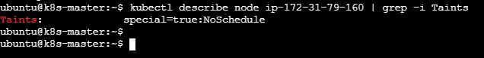

Step 2: Create the Pod with a matching toleration
Create tolerant-pod.yaml and add
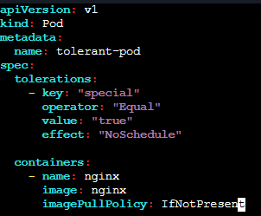

Save and exit.

Step 3: Apply
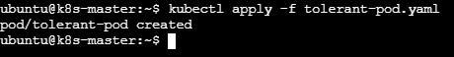

Step 4: Check the Pod

Task 3: Use NodeSelector to Schedule a Pod on a Specific Node Label a node with env=dev. Create a pod with a nodeSelector that schedules it only on the node labeled env=dev.

Step 1: Label the node

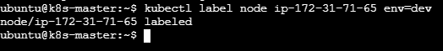

Verify:
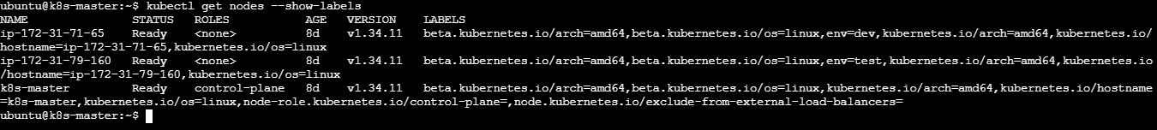

Step 2: Create the Pod
Create nodeselector-pod.yaml and add:
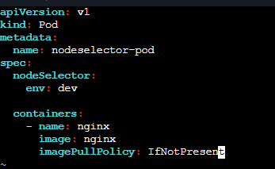
Save and exit.

Step 3: Apply the YAML
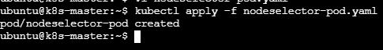

Step 4: Verify
Task 4: Use Node Affinity with Soft Scheduling Label a node with env=test. Create a pod with PreferredDuringSchedulingIgnoredDuringExecution node affinity, preferring to schedule it on a node labeled env=test. Remove the label and verify the pod continues to run.

Step 1: Label the node
Verify:
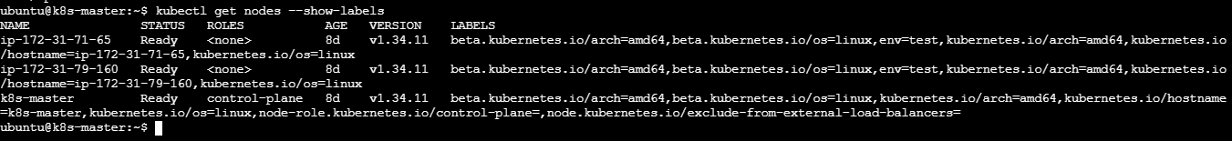

Step 2: Create the Pod
Create preferred-affinity.yaml and add:
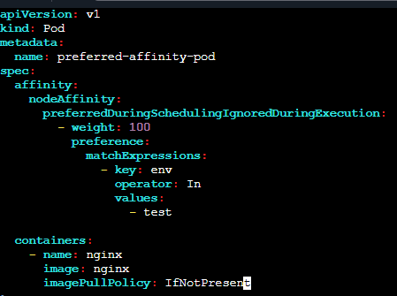
Save and exit.

Step 3: Apply
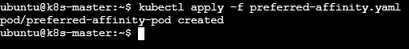
Check where it is running:

Step 4: Remove the label
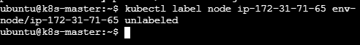
Verify:
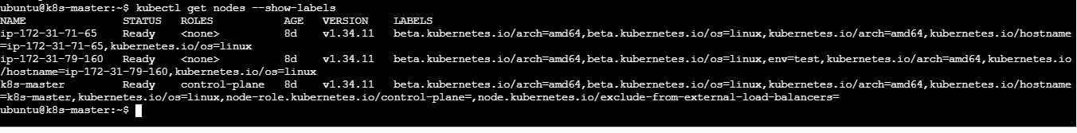

Step 5: Verify the Pod continues running
Task 5: Implement Node Affinity with Hard Scheduling Create a pod with RequiredDuringSchedulingIgnoredDuringExecution node affinity, ensuring it will only be scheduled on a node labeled env=prod. Verify the pod cannot be scheduled if no node has the env=prod label.

Step 1: Create the Pod YAML
Create required-affinity.yaml and add:
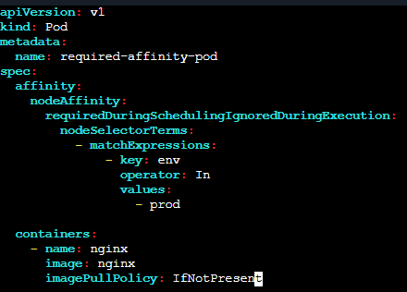
Save and exit.

Step 2: Make sure a node has env=prod

Verify:
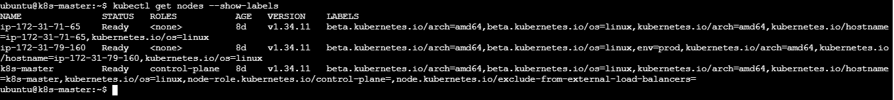
Step 3: Create the Pod
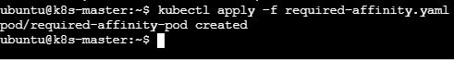
Check where it is running:
Step 4: Prove hard scheduling
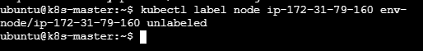
Verify:
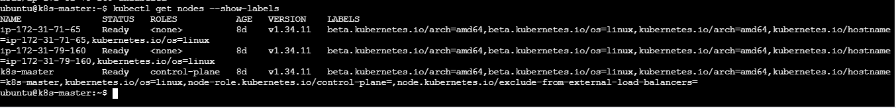

Because the Pod is already running, IgnoredDuringExecution means removing the label does not evict the existing Pod.
Now delete the Pod:
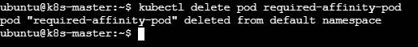
Recreate it:
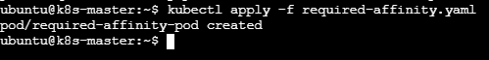
Check where it is running:
Step 5: Verify the reason
At the bottom under Events, you should see a scheduling message indicating that nodes don't match the Pod's node affinity/selector

Step 7: Make it schedulable again
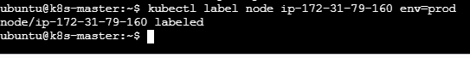
It should change from: Pending to running

Task 6: Taint a Node and Use NoExecute with Toleration Seconds Taint a node with special=true:NoExecute. Create a pod with a tolerationSeconds field (e.g., 60 seconds) and observe it gets evicted after 60 seconds on the tainted node.

Step 1: Make sure the node is schedulable
From your previous task, you may have removed the special=true:NoSchedule taint. Check:
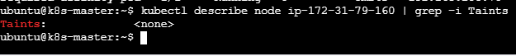
As we see none we can continue.

Step 2: Taint the node with NoExecute
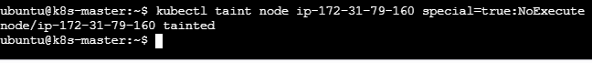

Verify:
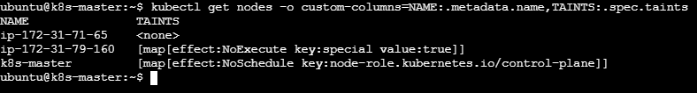

Step 3: Create the Pod with 60-second toleration
Create: vi noexecute-pod.yaml and add
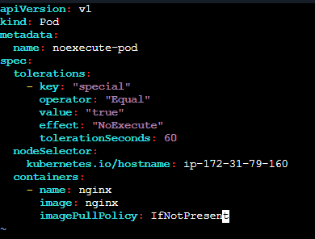
Save and exit.
Step 4: Create the Pod
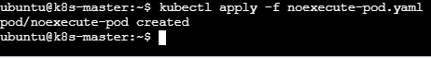

Check where it is running:
Step 5: Watch the Pod
Initially it is running

After 60 sec it gets deleted/terminated
